Happy Birthday Dr. Seuss!  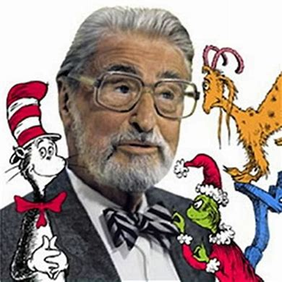Try writing your first name backwards and sound it out. It’s fun! | National Anthem  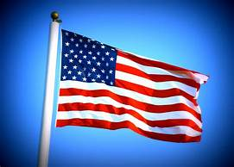  What is our National Anthem? What is the meaning of the National Anthem? | Dentist Day  What was the purpose of this day?
Girl Scout Day  Name one person who is being recognized on this special day? | Work-at-Home  Choice Board  Library K-5th  March/April 2021  Rules:  - Have fun!  - Complete at least 3 squares each week in any order you choose.  - Cross out the box as you complete it!  - Take breaks!! Don’t try to finish everything in one day. Pace yourself throughout the week!  - SHARE- Take photos and share with family, friends and Mrs. Arriola.  - librarymachananao@gmail.com  - Enjoy and treasure family time.  Visit the School Website http://machananaoelementaryschool.weebly.com/and check the Library section and OPAC.  New Link- EBSCO  Epic- wpd9579 | Giant Panda Bear Day  Do Panda Bears hibernate?
Submarine Day  Read a non-fiction book on Submarines or information on the Lesson Plan  “Nonfiction” refers to literature based in fact.  What 3 facts did you learn?  Share with your parents. |  | St Patrick’s Day  Read a fiction book or short passage on the lesson plan.  “Fiction” refers to literature created from the imagination.  Who is about?  What happened?  When did it happened?  Where did the story take place?  Why did it happened?  How did it happened?  K-2nd - Draw a picture of your favorite character.  3rd-5th – Draw your favorite scene.
April Fools’ Day  Play a trick on someone but be safe.  Share by writing what you did. If you have pictures, even better. Have fun! Email Mrs. Arriola. |  | Find a Rainbow Day  Read the facts on Rainbow and draw a beautiful rainbow.  Go outside and find a rainbow.
Zoo Lover’s Day  Write about your favorite zoo animal.  If you have access to the internet, take a virtual tour to many Zoos around the world. |  | Me time…..Read a book that you enjoy. Relax and have fun.
National Dolphin Day  Read the information on Dolphins. List 3 facts you learned about dolphins.  Draw a picture of a dolphin(s) with the 3 facts listed. | Earth Day  How can we take care of our Earth? What are the 3 Rs? | World Penguin Day  Read cool facts about penguins on the lesson plan.  With thousands of penguins in one area, how does the mommy penguin find their little penguins to feed them?
A Primary Kind of Life © 2020

